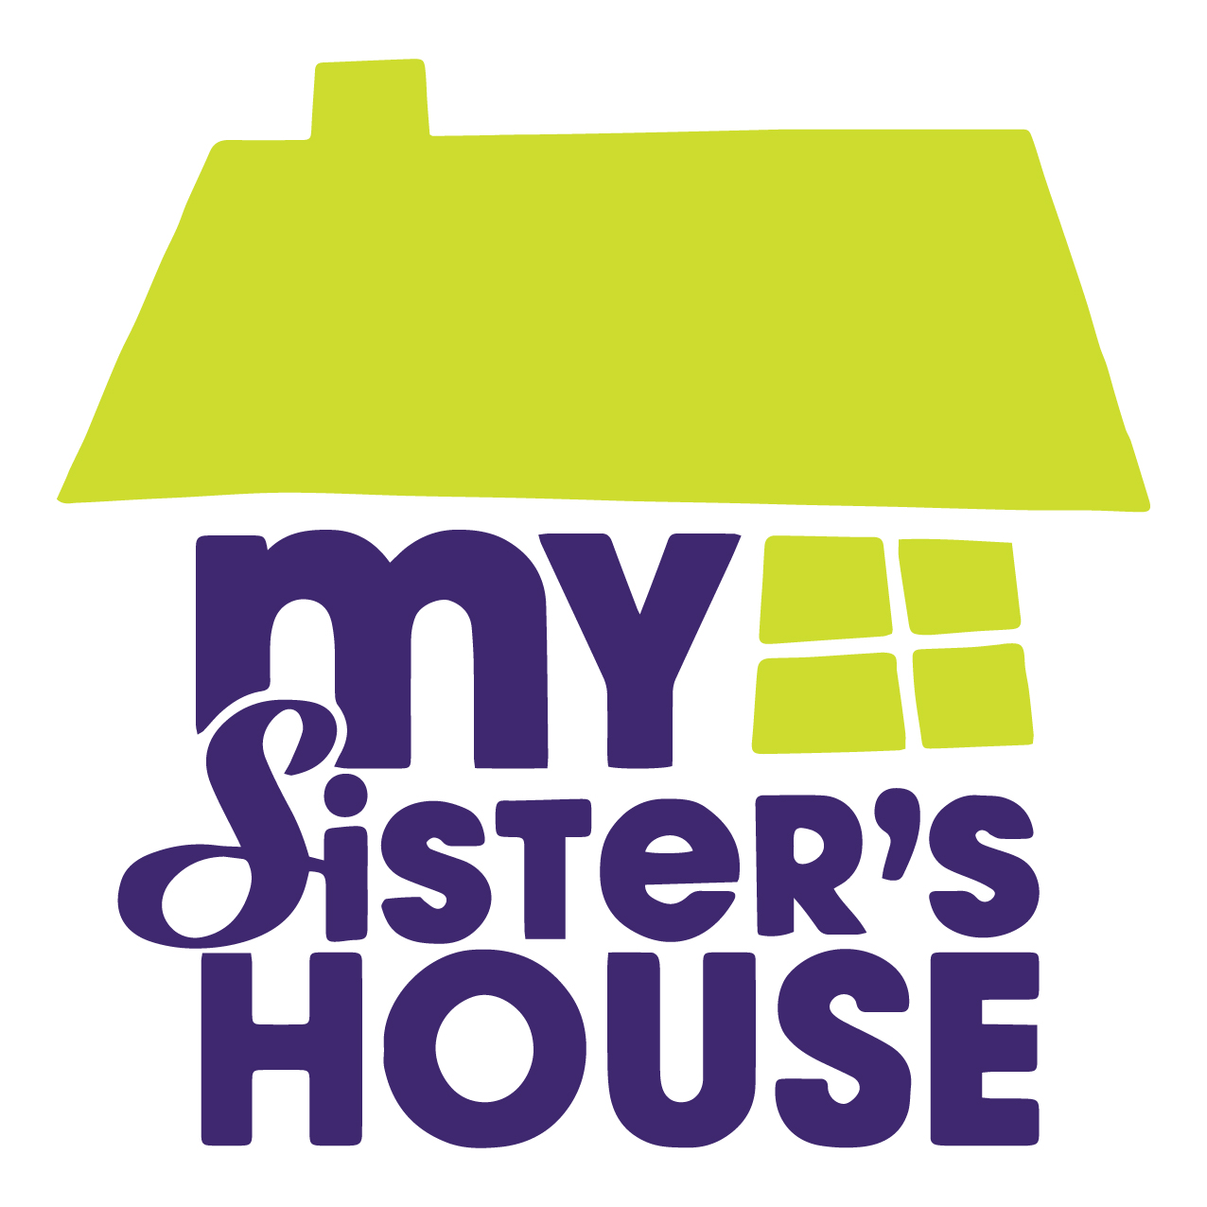
CONTACT
Tosha Connors
CEO, My Sister’s House, Inc.
Tosha@mysistershouse.com
843-747-4069

For Immediate Release: August 13, 2019

MY SISTER’S HOUSE ANNOUNCES NEW LOCATION TO INCREASE COMMUNITY SERVICES

My Sister’s House, Inc., the community’s longest operating domestic violence organization, is pleased to unveil the location of their new administrative office on Spruill Avenue in North Charleston.

Since 2002, My Sister’s House has operated out of two locations - a client-centered safe shelter and an administrative site for client follow-up, volunteer interviews, training, and donation drop off.
My Sister’s House has recently secured a new location with the goal of growing its preventative services to be more responsive to community needs. In addition to serving as the organization’s administrative office, the new location will also offer a space for individual therapeutic services, support groups, community trainings, and extended case management. Only those staff who have direct responsibility for daily shelter activities will continue to work from the shelter, which remains fully operational in its current, private location.
On November 18, My Sister’s House will move out of its current administrative building in West Ashley and into the new space at 3775 Spruill Avenue. “This move is the first step in our larger vision to develop a more community-centered service model,” says Tosha Connors, CEO. “We know that 1 in 3 women in our community is effected by some form of domestic violence and not all of those victims need shelter. This new, larger office will allow us to serve the greater tri-county population in a more meaningful way.

“We’ve been serving victims of domestic violence for nearly 40 years,” says Connors. “Now we’re going to be able to expand and strengthen that service and lead the charge against domestic violence in the tricounty region.”

###

My Sister’s House, Inc. is a registered 501c3 nonprofit organization that empowers survivors of domestic violence. To learn more about the organization’s 40-year legacy and vision for the future, visit www.MySistersHouse.org.

