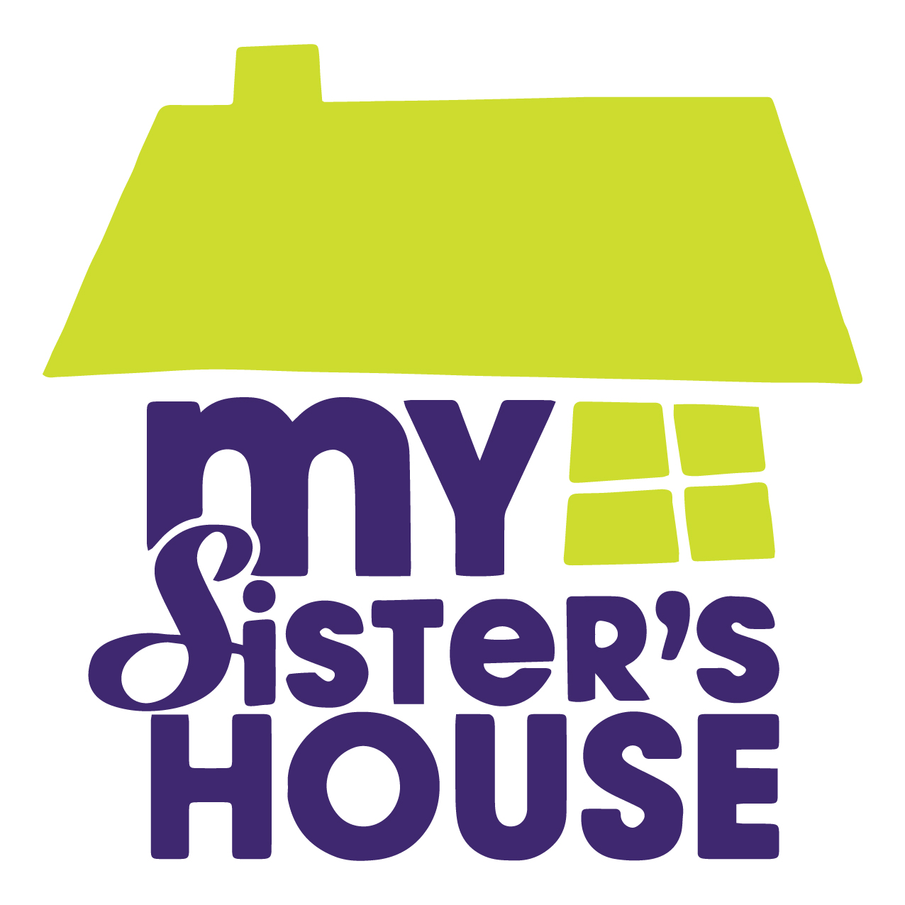
CONTACT
Tosha Connors
CEO, My Sister’s House, Inc.
Tosha@mysistershouse.com
843-747-4069

For Immediate Release: August 19, 2019

MY SISTER’S HOUSE UNVIELS INAGURAL ‘SPEAK UP SOUTH CAROLINA’ CAMPAIGN AS PART OF DOMESTIC VIOLENCE AWARENESS MONTH

My Sister’s House, Inc., the community’s longest operating domestic violence organization, is excited to announce its first “Speak Up South Carolina” campaign in honor of Domestic Violence Awareness Month in October.

Historically, My Sister’s House has hosted its Walk A Mile In Her Shoes advocacy march and annual luncheon fundraising event every October to bring awareness to domestic violence issues in the Lowcountry. “This year we wanted to do something bigger,” says Tosha Connors, CEO.

This year, in addition to their signature events, My Sister’s House is launching a full-scale campaign to challenge members of the community to stand up and speak out about domestic violence. The goal of Speak Up SC is to engage every day people as advocates and to challenge friends, neighbors, supporters, and local leaders to contribute to the conversation surrounding domestic violence in the Charleston community. “We are on a mission to make a real, actionable impact on domestic violence in the Lowcountry and we’re asking the community to help us lead the way,” says Rock Amick, Board Chair of My Sister’s House. “The primary victims of domestic violence in our community are women and children. They carry the scars and may suffer a lifetime of emotional trauma as a result. It would be a mistake, however, to assume that this societal problem does not affect our entire Lowcountry community. As such, we must share in the effort to seek out and support solutions to end this scourge.”

Speak UP SC offers something for everyone. Over the course of one week, My Sister’s House will host three events with the goal of elevating the conversation about domestic violence in the tricounty: a free, open Town Hall discussion on harnessing the power of individuals to make an impact on Monday, October 14th, the My Sister’s House Annual Luncheon at the prestigious Hotel Bennett on Wednesday, October 16th for individuals and businesses that are passionate about investing in change, and the kid-friendly Walk A Mile advocacy march in Park Circle on October 19th where friends and families come together in support of domestic violence victims in our community. In addition to the events, there will be opportunities throughout the month of October for individuals to host online fundraisers and become social media ambassadors.

“Domestic violence can be seen as a common thread connecting homelessness, the opioid epidemic, and our struggling education system,” says Amick. “It also contributes to negative economic impacts on small business and puts a strain on already limited community and social resources. It’s time to change the narrative and tell the full story. Speak Up South Carolina is a chance to educate and empower our community about the true and lasting effects of domestic violence. Together, as a community, we can end Domestic Violence in the Lowcountry.”

More information about Speak Up South Carolina, including registration for all three events, can be found online at www.MySistersHouse.com/speakup. If you’re interested in getting involved or sponsoring the campaign, please contact Tosha Connors at Tosha@mysistershouse.com.

###

My Sister’s House, Inc. is a registered 501c3 nonprofit organization that empowers survivors of domestic violence. To learn more about the organization’s 40-year legacy and vision for the future, visit www.MySistersHouse.org.

