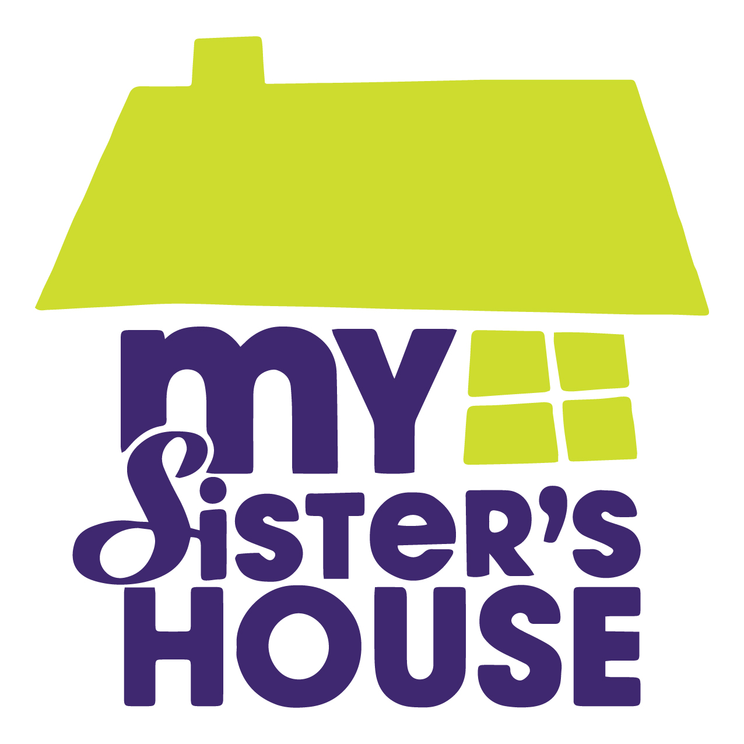
CONTACT
Amber Cook
Volunteer Coordinator
Amber@mysistershouse.com
843-225-6312

For Immediate Release: May 22, 2019

MY SISTER’S HOUSE ANNOUNCES ANNUAL WALK A MILE EVENT FOR DOMESTIC VIOLENCE AWARENESS

My Sister’s House, Inc., the community’s longest operating domestic violence organization, is pleased to announce that this year’s Walk a Mile in Her Shoes event will be held on Saturday, October 19th from 8am – 12pm at the Felix C Davis Community Center in Park Circle.

This nationally-branded event is a chance for the community to come together and take a stand against domestic violence in the tri-county region. The cornerstone of the event is a one-mile advocacy walk where male participants are encouraged to don high heel shoes as a symbol of support for the 1 in 3 women in the Unites States who are victims of domestic violence.

“Our goal is to make this year’s walk the biggest, most impactful event yet,” says Tosha Connors, CEO of My Sister’s House. “With 1 in 3 women being affected by domestic violence, everyone knows someone who is a survivor. This event is a chance to bring your friends and family out and honor the survivors in our community in a fun, lighthearted way.”

In additional to the one-mile walk, the event will also include a family-friendly festival with a DJ, activities for children, food for purchase, raffle prizes, and high heel sprint races.

Tickets for the event are on sale now and can be purchased on the My Sister’s House website at www.MySistersHouse.org/walk-a-mile-2019. Tickets are $25 per person with an event t-shirt and $20 without. Children 10 and under are free of charge. Participants will have the option to register as a walker, survivor, or first responder. Survivors will receive a custom t-shirt and the opportunity to lead the walk alongside the My Sister’s House Survivor’s Advisory Council.

“Our goal is to register 200 walkers this year and raise $20,000 for victims and their children,” says Connors. Proceeds of the event will help fund vital initiatives at MSH including the new Transitional Housing Program which aims to combat the hardship of rising housing costs by providing financial assistance and extended case management for women exiting the shelter.

My Sister’s House is now accepting sponsors for this event. If you’re interested in learning more about sponsorship opportunities, contact Amber Cook at Amber@mysistershouse.com.

###

My Sister’s House, Inc. is a registered 501c3 nonprofit organization that empowers survivors of domestic violence. To learn more about the organization’s 40-year legacy and vision for the future, visit www.MySistersHouse.org.

